

**CSE488 (Section 1)**

**[Spring 2023]**

**Lab Assignment Submission Report**

**Assignment Title:** Setting up Cloudera VM and Executing Word Count Problem using MapReduce

**Submitted by:**

**Sazzad Hossen**

**2019-1-60-063**

Setting up Cloudera VM



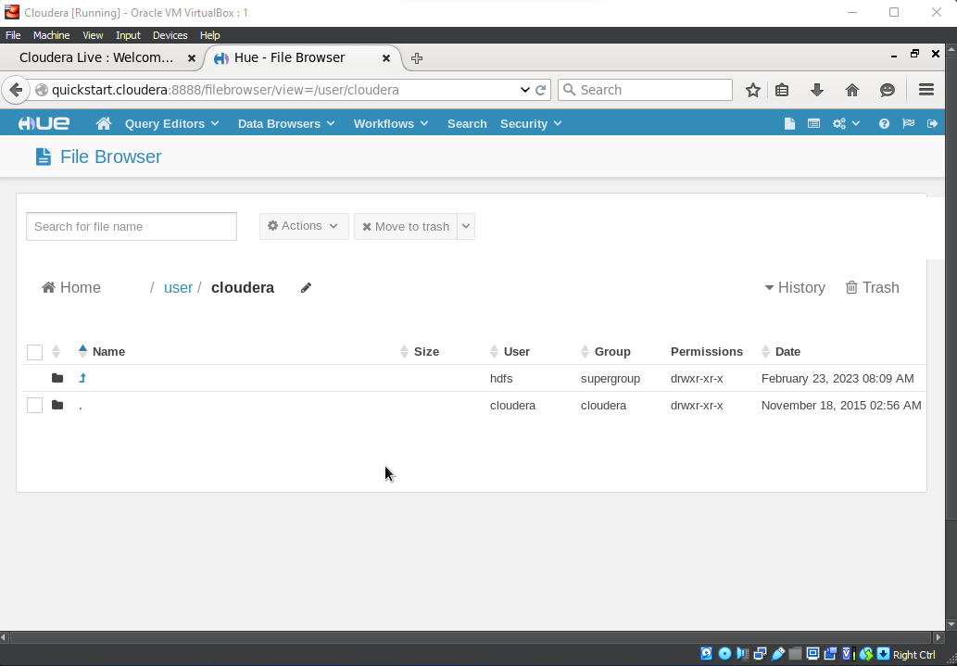

Executing Word Count Problem using MapReduce

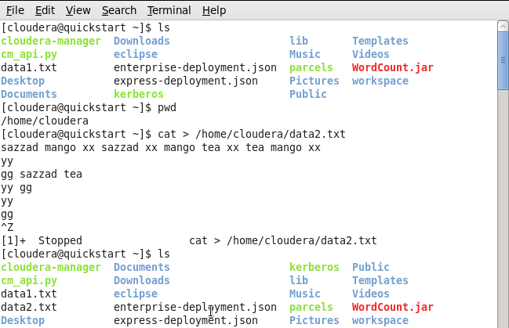

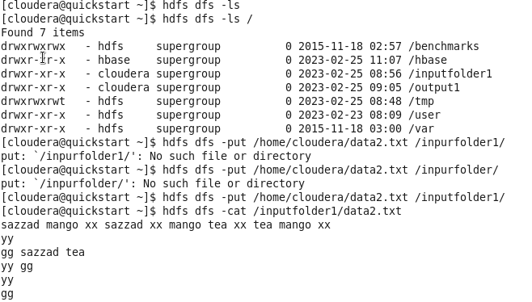

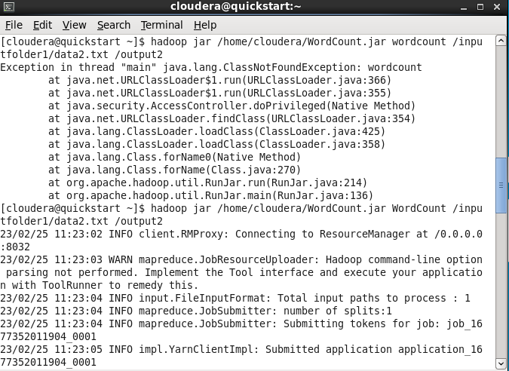

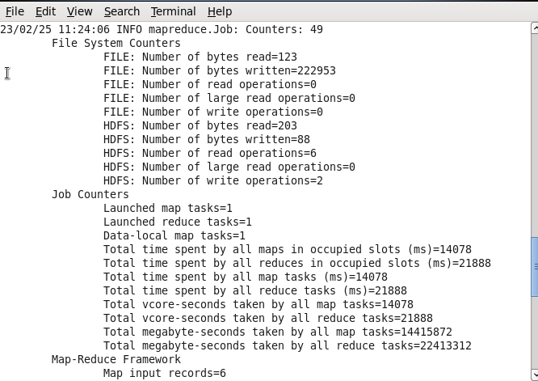

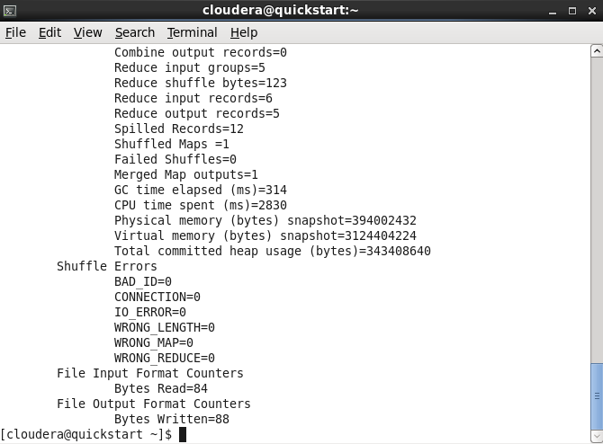

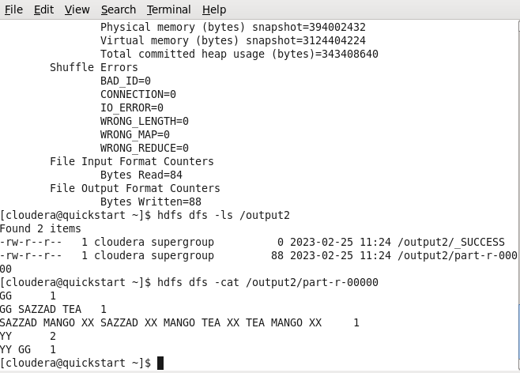

**Learning Outcomes**

In this lab learned how to install Hadoop on my virtual box and learned how to solve word count problem. Also learned how to execute a problem with MapReduce.